BUPATI MINAHASA TENGGARA
SURAT IZIN
NOMOR ...................

TENTANG
............................................

Dasar : a. ..................................................................................................
..................................................................................................
b. ..................................................................................................
……………………………………………………………………….

MEMBERI IZIN:

Kepada
Nama : ......................................................................................................
Jabatan : ......................................................................................................
Alamat : ......................................................................................................
Untuk : ................................ ................................ ....................................

Ditetapkan di ....................
Pada tanggal ....................
Pj. BUPATI MINAHASA TENGGARA,

Ir. RONALD T. H. SORONGAN, M.Si

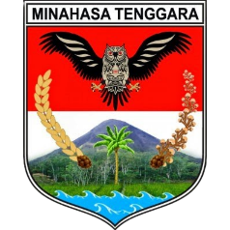 | PEMERINTAH KABUPATEN MINAHASA TENGGARA  ………………………………………………..  ………………………………………………………………………………………..  ………………………………………………………………………………………...  ………………………………………………………………………………………
SURAT IZIN
NOMOR ...................

TENTANG
............................................

Dasar : a. ................................................................................................
b. ................................................................................................

MEMBERI IZIN:

Kepada
Nama : ....................................................................................................
Jabatan : ....................................................................................................
Alamat : ....................................................................................................
Untuk : ................................ ................................ ..................................

Nama Jabatan,

Nama
Pangkat/Golongan
NIP

