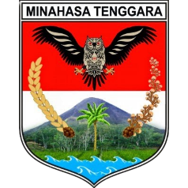 | PEMERINTAH KABUPATEN MINAHASA TENGGARA  ……………………………………………….  …………………………………………………………………………………………………  …………………………………………………………………………………………………  …………………………………………………………………………………………………

Tempat, Tanggal Bulan dan Tahun

Nomor :
Sifat :
Lampiran :
Hal :

Yth. …………………………………
di-
………………

.....................................................................................................................................................................................................................................................................................................................................................................................................................................................................................................................................................................................................................................................................................................................................................................................................
..........................................................................................................................................................................................................................................................................................................................................................................................................................................................................................................................................................................................................................................................................................................................................................................................................

Nama Jabatan

Nama
Pangkat/Golongan
NIP

